# **About Me**

Village 88’s First Assignment

Hello. **My name is Joshuel Ernest Q. Simbulan**. I'm a student developer working towards the domain of web development. I am a fourth-year college student at the Technological University of the Philippines in Manila. My experience in programming started four years ago from a [youtube video](https://www.youtube.com/watch?v=mElVGah7Epg) that appeared on my feed when I was in senior high school. Since then, I started studying on platforms like [Freecodecamp](https://www.freecodecamp.org/), [Codecademy](https://www.codecademy.com/), and [The Odin Project](https://www.theodinproject.com/). What really gave me the confidence and skills I needed was [Harvard’s CS50x.](https://cs50.harvard.edu/x/2024/) It equipped me with the safety hat and hammer I needed to survive in this CS/IT study environment and industry that is surrounded by [anxiety and fear.](https://en.wikipedia.org/wiki/Impostor_syndrome)

I currently know the MERN stack but have a weak point in terms of practical knowledge. My thesis is about vehicle detection using YOLOv8 that will be deployed as an API and using web tools such as Flask and MongoDB on the server-side. I'm also learning the Godot game engine for game development to develop a mobile game similar to Scrabble for a local company and to also enhance my hobby side of life. I like playing survival video games such as PZ and DST and watching movies and series with genres similar to the Before Sunrise trilogy, La La Land, Bojack Horseman, The Office, and The Bear.

Until now, all of my learning has involved watching videos, asking questions on forums, and trying to build projects with them. **I heard about Village 88 from an online friend**. Joining [Village 88](https://village88.com/) is a great opportunity for me. It will give me more experience working with people. It will also give me more knowledge about best practices in the industry which are difficult to find. Ultimately, the curriculum of Village 88 is too good to pass up. For that…Thank you for this opportunity!

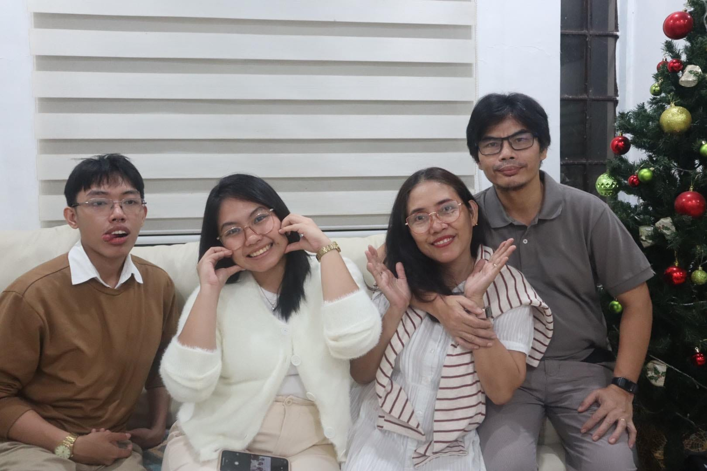

Me and my family last Christmas. I’m the one on the leftmost side, followed by my sister, mother, and father. **They are my inspiration to finish this course.**